Healthy lifestyle
How to be healthy
(Picture images.huffingtonpost.com)

Diet
Biochemicals are essential to the human diet. All biochemicals should be taken in consideration.
- The RDA (recommended daily allowance) for protein is about 46 grams. According to your meal plan, you are eating about 166 grams of protein. Foods like meat,and eggs are a good source of protein, but eat in consideration because too much is bad for you.
- Another biochemical is carbohydrates and the RDA intake is about 130grams. You are eating about 350 grams of carbohydrates. Carbohydrates are a good energy source for quick energy, but too much of it can be bad. Foods like bread, grain, dairy contain a lot of carbs. You need to count your carbs since you are diabetic.
- In addition, fiber is an essential biochemical. The RDA is 25 grams of fiber per day. Fiber is in a lot of foods like vegetables, fruit,and beans, so it's easy to eat too much fiber. Taking in too much fiber can make you feel bad. Fiber is good for slowing down the rate of sugar in the bloodstream, which keeps your blood glucose from rising too high and fast (ucsfbenioffchildrens.org).
- Lipids is the fourth biochemical, are fats. The RDA is 20-35% of your meal should be fats, which would be about 500 grams of fat. However, you are eating about 170 grams of fat. 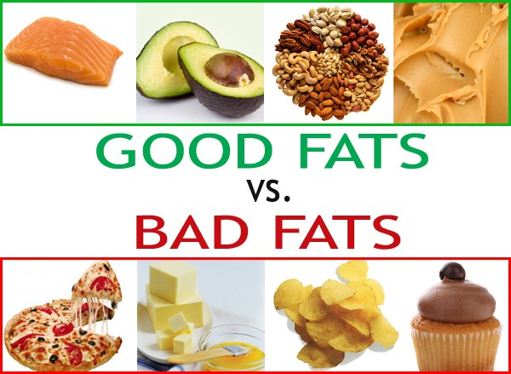
- (Picture crunchfitness.ie)
- There are multiple types of fat that you may consume in your daily life. Some types include unsaturated fats, saturated fats, and Trans fats.
- Unsaturated fats are the healthiest to consume because they typically come from plants or plant-based products such as nuts and seeds.
- Saturated fats is what you need to cut down on. Also known as “solid fats” get their name because while they are at room temperature, they are still in solid form. Fats from animal products, butter, milk fat, and coconut oil are all examples of saturated fats. Consuming too much saturated fats may be bad for you so be careful of how much you consume.
- Another type of fat you may want to stay away from is Trans fat. This type of fat is typically made with vegetable oils or any other type of oil.Stay away from teams fat and saturated fat since you are diabetic.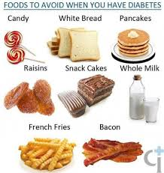(picture fggam.org)
- Good fats are monounsaturated polyunsaturated and omega 3. Monounsaturated fats can be found in canola oil, olive oil, peanut oil, and avocados. They can help lower your blood cholesterol level.(picture s-media-cache-ak0.pinimg.com)
- Examples of Polyunsaturates are nuts, seeds, algae, and leafy greens. Eggs are also really good source of omega 3.
Processed vs Whole Foods
Whole Foods are healthier and better choice. Processed Foods can have a lot of added chemicals and are mostly made up of bad fats. The ingredients can be made up of chemicals and not actual foods.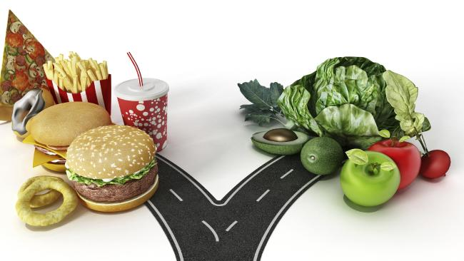(picture cdn.newsapi.com)
Whole Foods are natural and healthy with vitamins and nutrients. Healthy foods also have nutrients that can prevent diseases like cancer or diabetes. They will also provide you with energy, unlike processed foods which will make you tired. Furthermore, HFCS and sodium are in many processed foods. HFCS; which is high fructose corn syrup, is a sweetener that is made from corn.
What they all have in common is, that there can be a high amount of sugar (HFCS) and salt in processed foods. Foods like canned soups or sauces can have a high amount of added sodium for perseveration and taste uses. As for sugars, it can be added in bread just to add color (eatright.org). 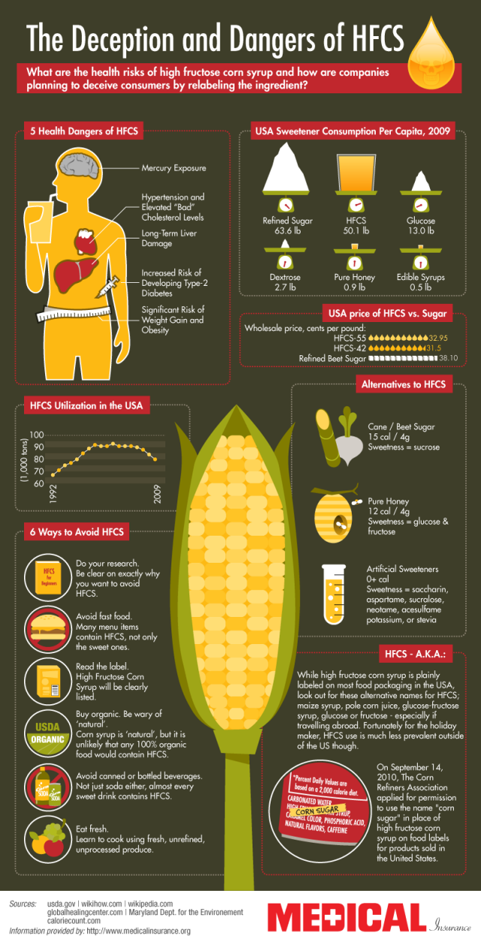(Picture thumbnails-visually.netdna-ssl.com)

Obesity
Your current diet could lead to OBESITY. Obesity is a disorder where you have too much fat tissue. Your eating habits are not the best. Eating at a fast food restaurant like Chick-FI-LA or Sophie’s five times a week is not healthy. On a typical day, you are eating a lot of foods that are high in Protein, sodium, and carbohydrates. According to Endocrineweb.com, those are the three nutrients that diabetic people should watch out on.
- You should be eating about 2,000 calories a day, but you are eating around 3,000 a day. All the extra calories are being stored as fat.
- Unhealthy eating also contribute to obesity. Eating large amounts of food that are processed, comfort eating; which is when you eat when you're bored or sad, eating out a lot can overtime lead to obesity. The phrase “my eyes were bigger than my stomach”, means overeating or eating more than you should.
- 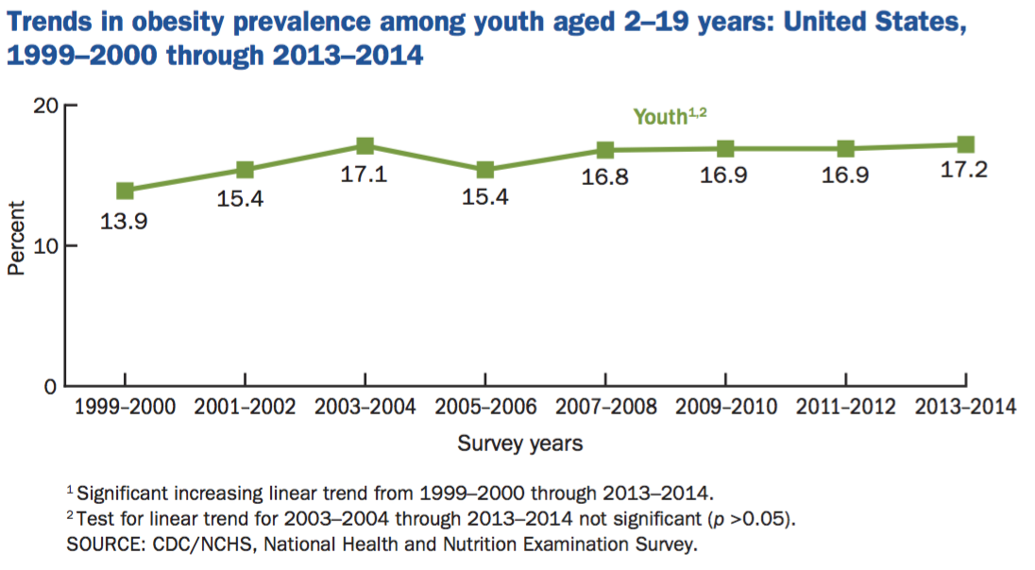
- (Picture from stateofobesity.org)
- According to stateofobesity.org, “Since 1980, the childhood obesity rates (ages 2 to 19) have tripled — with the rates of obese 6- to 11-year-olds more than doubling (from 7 percent to 17.5 percent) and rates of obese teens (ages 12 to 19) quadrupling from 5 percent to 20.5 percent.”
- Also, statistics show that “If obesity rates stay consistent, by 2030, 51 percent of the population will be obese by 2030” (obesity campaign.org).
- That could be you. You could turn into another statistic if you don't start this healthy lifestyle now.
- (Picture s-media-cache-ak0.pinimg.com)
- It doesn't stop at obesity, according to obesitycampaign.org, “Obesity is linked to more than 60 chronic diseases”. You could get strokes, develop heart disease, high blood pressure, and breathing problems. The list goes on.
Cancer
Everything causes cancer. Your diet is not that bad, weighing 132 for a 5’5 18 year old female. Your BMI (body mass index) is 22, which is normal. However for being diabetic you need to be careful with the carbohydrates you eat. Apps can help you keep track.
- First off your family has a history of colon cancer, so you are in high risk for that. Early diagnosis is the key. Don't worry though, healthy lifestyle can help prevent cancer!
- Also, I would like to say you are doing a good job of staying active by working out here tiene a week, which is full of high intensity. Keep up the great work and working out more wouldn't hurt you! Being physically active will help lower your risk of cancer.
- (Picture everydayfeminism.com)
- Ethnicity also plays a role in cancer. According to U.S Department of Health and Human Services, “African Americans had the highest death rate and shortest survival time for most cancers of any racial and ethnic group in the nation as of 2005”. Also death rates are higher for African Americans than other ethnic groups with Colorectal cancer (colon cancer).
Diet + Exercise plan

DIET PLAN | DAY 1 | DAY 2
Breakfast | •1 orange, medium size  •1 ½ cup Cheerios Cereal | •1 Whole Grain Oat Bran Bagel  •1/2 Cup Blueberries  •1 Tablespoon Creamy Peanut Butter, unsalted
Lunch | •lentil salad with chicken  •1 large whole wheat pita bread  •2/3 cup nonfat strawberry frozen yogurt | •chicken burritos  •1 Cup Tossed Salad Mix  •1 Tablespoon Vinegar & Oil Salad Dressing  •1 Cup Fresh Pineapple
Dinner | •grilled steak with beets & radish  •3/4 cup cooked brown rice  •1 cup steamed spinach | •vegetable & sausage skillet  •1 Cup Tossed Salad Mix  •2 Tablespoons Vinegar & Oil Salad Dressing  •1 Nectarine, medium
Snacks | •1 ½ cup cantaloupe melon  •⅔ cup low fat, low sodium cottage cheese  •4 tablespoon prepared hummus  •4 ounces carrot sticks | •1 Apple, small  •1 Cup Nonfat Vanilla or Lemon Yogurt, Sweetened with Low-Calorie Sweetener
Beverages | •water  •camomile tea  •1 cup 1% milk | •2 cup 1% milk

EXERCISE PLAN | DAY 1 | DAY 2 | DAY 3 | DAY 4 | DAY 5 | DAY 6 | DAY 7
 | 3 rounds:  •10 strict knees-to-elbows  •155lb. power snatches,10 reps  •10 strict knees-to-elbows  •10 burpees | Rest day | 3 rounds:  •5 minutes of running  •5 minutes of rest | 27-21-15 reps for time of:  •165lb. back squats  •Handstand push-ups | Complete rounds for 20 minutes of:  •5 pull-ups  •10 push-ups  •15 squats | 5 rounds for time of:  Swim 50 meters  •25 push-ups | Rest day

- Exercising is one of the best things to do. There are so many benefits to it!
- Exercising produces endorphins, which is a chemical that makes you happy and in a overall good mood. Exercising can help you sleep better because you get more tired.
- You'll look fit and be toned since you are burning all those calories.
- (Picture Team USA.org)
- Lowers the risk of some diseases like type 2 diabetes and high blood pressure. It also helps loose weight. It also helps the heart, and the whole body.
- Exercising and working out also helps you become flexible. Flexible means being able to bend and twist without breaking anything. Stretching is how you become more flexible. When you have good flexibility it reduces the chance of injury and helps loosen your muscles. Loosen, meaning not being sore or tight.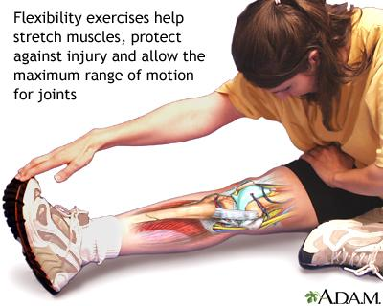
- (Picture from medlineplus.gov)

Works Cited
"African Americans and Cancer." Fred Hutch. Web. 23 Oct. 2016.
By Bringing Together Leaders from across Industry,academia and Public Health with Policymakers and Their Advisors, TheCampaignprovides the Information and Guidance That Decision-makers Need to Makepolicychanges That Will Reverse One of the Nation’s. "The Campaign to End Obesity." The Campaign to End Obesity. N.p., n.d. Web. 23 Oct. 2016.
By Giving Children a Healthy Start, They Will Be on a Much Better Trajectory for Lifelong Health as They Age. "Obesity Rates & Trends Overview." : The State of Obesity. Web. 23 Oct. 2016.
Deception-and-dangers-of-hfcs. 2016. Web. 23 Oct. 2016.
Diabetic-avoid-foods. 2016. Fggam.org. Web. 23 Oct. 2016.
Good_foods. 2016. Crunchfitness.ie. Web. 23 Oct. 2016.
"HTTPS, Secure HTTPS." SpringerReference. Print.
"Meal Planning for Children with Type 1 Diabetes." EndocrineWeb. Web. 23 Oct. 2016.
Michelle-flexing. N.d. Everydayfeminism.com. Web. 23 Oct. 2016.
Nike. 2016. Nike.com. Web. 23 Oct. 2016.
"Processed Foods: What's OK, What to Avoid." Www.eatright.org. Web. 23 Oct. 2016.
USA Field Hockey. 2016. Teamusa. Teamusa,org. Web. 23 Oct. 2016.
"Why Fiber Is So Good for You." UCSF Benioff Children's Hospital. Web. 23 Oct. 2016.
2016. Huffingtonpost.com. Web. 23 Oct. 2016.
2016. Pintrest. Web. 2 Nov. 2016. <https://s-media-cache-ak0.pinimg.com/736x/29/05/83/290583e76f19430675faa6b03f194699.jpg>.
2016. Web. 23 Oct. 2016. <http://cdn.newsapi.com.au/image/v1/2c318112d60c4a8e311549f0df32be5e>.

